Project Title
Local Sequence Alignment of DNA and Protein Sequences
Project Report submitted for the partial fulfilment of grade for the course

Data Structures and Algorithms -3 (25CS2103E)
in

A.Y. 2026-2027

Submitted by
P. Anuradha Nandini – 2520030171
B. Jamuna – 2520030408
B. Pemesh - 2520030388
Team Number: 17
Section: 07

Under the guidance of

Dr S. Madhavi

CSE
Hyderabad-500090, Telangana, India.

K L (Deemed to be) University
DEPARTMENT OF COMPUTER SCIENCE ENGINEERING / COMPUTER SCIENCE AND INFORMATION TECHNOLOGY/ARTIFICIAL INTELLIGENCE & DATA SCIENCE



DECLARATION

The Mini Project Report entitled “Local Sequence Alignment of DNA and Protein Sequences
” is a record of Bonafide work of P. Anuradha Nandini – 2520030171, B. Jamuna – 2520030408, B. Pemesh - 2520030171. submitted in partial fulfillment for the award of B. Tech in Computer Science and Engineering/Computer Science and Information Technology/ Artifical Intelligence & data Science to the K L University. The results embodied in this report have not been copied from any other departments/University/Institute.

P. Anuradha Nandini - 2520030171
B. Jamuna - 2520030408
B. Pemesh - 2520030388

K L (Deemed to be) University
DEPARTMENT OF COMPUTER SCIENCE ENGINEERING / COMPUTER SCIENCE AND INFORMATION TECHNOLOGY
CERTIFICATE

This is to certify that the mini project based report entitled “Local Sequence Alignment of DNA and Protein Sequences” is a bonafide work done and submitted by – P. Anuradha Nandini – 2520030171, B. Jamuna – 2520030408, B. Pemesh – 2520030388. In partial fulfillment of the requirements for the award of the degree of BACHELOR OF TECHNOLOGY in Department of Computer Science Engineering, K L (Deemed to be University), during the academic year 2026-2027.

Signature of the Supervisor

Signature of the HOD Signature of the External Examiner

ACKNOWLEDGEMENT

The success in this project would not have been possible but for the timely help and guidance rendered by many people. Our wish to express my sincere thanks to all those who has assisted us in one way or the other for the completion of my project.

Our greatest appreciation to my guide, <<Guide Name>>, <<Designation>>, <Department>> which cannot be expressed in words for his/her tremendous support, encouragement and guidance for this project.

We express our gratitude to Dr. P.Venkateshwar Rao (CSE)/Dr. Khaja Shareef (CSIT)/ Dr. Sreenath Itikela (AI&DS), Head of the Department for Computer Science Engineering/ Department for Computer Science and Information Technology/Department of Artificial Intelligence and Data Science for providing us with adequate facilities, ways and means by which we are able to complete this project-based Lab.

We thank all the members of teaching and non-teaching staff members, and also who have assisted me directly or indirectly for successful completion of this project. Finally, I sincerely thank my parents, friends and classmates for their kind help and cooperation during my work.

P. Anuradha Nandini - 2520030171
B. Jamuna - 2520030408
B. Pemesh - 2520030388

TABLE OF CONTENTS

S.No. | Contents | Page no.
1. | Abstract
2. | Introduction
3. | Literature survey
4. | Problem Statement and Objectives
5. | Hardware and Software requirements
6. | Implementation
7. | Results & Discussion
8. | Conclusion & Future Scope
9. | References

1.ABSTRACT

This project aims to develop a Java-based bioinformatics application for comparing DNA and protein sequences and identifying the most similar local regions between them. The system implements the Smith–Waterman algorithm, a dynamic programming technique used for local sequence alignment. It calculates alignment scores and identifies the optimal matching region between two input sequences. Users can enter or upload DNA or protein sequences and configure parameters such as match, mismatch, and gap scores. The application then generates the alignment matrix and performs traceback to produce the best local alignment. The results include the aligned sequences, alignment score, and percentage similarity, presented in an easy-to-understand format.
The application uses Java and two-dimensional arrays to construct and process the alignment matrix, demonstrating the practical use of data structures and algorithms in bioinformatics. It can support the identification of conserved regions, analysis of mutations and sequence variations, and comparison of genes or proteins. The project provides an interactive platform for understanding sequence alignment while demonstrating how computational techniques can be applied to biological data analysis. Overall, the system offers a simple and effective approach to performing local sequence comparison using the Smith–Waterman algorithm.

Team Members:
- P. Anuradha Nandini – 2520030171
- B. Jamuna – 2520030408
- B. Pemesh – 2520030388

- INTRODUCTION

Bioinformatics is an interdisciplinary field that combines biology, computer science, and mathematics to analyze and interpret biological information. With the rapid advancement of DNA and protein sequencing technologies, large amounts of biological sequence data are being generated. Comparing these sequences is important for identifying similarities, conserved regions, mutations, and evolutionary relationships. However, manually analyzing long biological sequences can be time-consuming and difficult. Computational sequence alignment algorithms provide an efficient way to perform this analysis.
This project focuses on developing a Java-based bioinformatics application for DNA and protein sequence alignment using the Smith–Waterman algorithm. The Smith–Waterman algorithm is a dynamic programming technique used for local sequence alignment. It identifies the most similar region between two sequences rather than comparing the entire sequences. This makes it useful when two sequences share similarity only in specific regions.
The proposed system allows users to enter or upload two biological sequences and specify match, mismatch, and gap scores. The application creates an alignment matrix, calculates the alignment scores, identifies the highest-scoring region, and performs traceback to generate the optimal local alignment. It also displays the alignment score and percentage similarity in an understandable format.
The project demonstrates the practical application of Java programming, two-dimensional arrays, dynamic programming, and bioinformatics concepts. The report covers the background of sequence alignment, the Smith–Waterman algorithm, system design and implementation, results, applications, limitations, and future enhancements.

- LITERATURE SURVEY

2.1 NCBI BLAST
NCBI BLAST is a widely used bioinformatics tool for comparing biological sequences against databases and identifying similar sequences. It supports nucleotide and protein sequence searches and can also align two or more sequences. Users can enter sequences directly or upload FASTA files. BLAST is highly useful for finding biologically related sequences, although it is primarily designed for database searching rather than providing a simple educational implementation of the Smith–Waterman algorithm.
2.2 EMBOSS Water
EMBOSS Water is a sequence alignment tool based on the Smith–Waterman local alignment algorithm. It is designed to identify the highest-scoring local regions between two biological sequences. The tool can be used with DNA or protein sequences and applies scoring parameters to calculate the best alignment. This project is closely related to the proposed system because it demonstrates the practical use of Smith–Waterman for local sequence comparison.
2.3 Biopython Pairwise Alignment
Biopython provides sequence-analysis functionality through its Bio.Align module and supports both global and local pairwise alignment. Its pairwise aligner can use the Smith–Waterman algorithm for local alignment and allows users to specify scoring parameters such as substitution scores and gap penalties. This provides a programmable approach to sequence comparison. The proposed project follows a similar algorithmic concept but implements the alignment process directly in Java for easier understanding and demonstration.
2.4 Smith–Waterman Alignment Calculator
The Smith–Waterman Calculator available through Bioinformatics Tools provides an interactive implementation of local sequence alignment. It displays the scoring matrix and traceback path, allowing users to understand how the optimal local alignment is obtained. It demonstrates the importance of initializing the matrix with zero values and selecting the highest-scoring cell for traceback. The proposed project is similarly focused on making the Smith–Waterman process understandable through an interactive alignment result.
2.5 Jalview
Jalview is a Java-based bioinformatics application used for viewing, editing, visualizing, and analyzing biological sequence alignments. It supports DNA, RNA, and protein sequences and provides several visualization and analysis features. It can also connect sequence alignments with structural and annotation information. Compared with Jalview's broader functionality, the proposed project focuses specifically on implementing local pairwise alignment using the Smith–Waterman algorithm in a simpler educational application.
2.6 Clustal Omega
Clustal Omega is a multiple sequence alignment program used for protein and DNA/RNA sequences. It generates high-quality multiple sequence alignments and uses guide trees and profile-based techniques to handle large datasets. It is mainly intended for aligning multiple sequences rather than focusing on a single pair of sequences. The proposed project differs by concentrating on pairwise local alignment and demonstrating the underlying Smith–Waterman algorithm.
2.7 MUSCLE
MUSCLE is another widely used sequence alignment approach designed primarily for multiple sequence alignment. It is useful for identifying conserved regions and relationships across several biological sequences. Such tools demonstrate how computational alignment can support biological analysis on larger datasets. The proposed project takes a more focused approach by comparing two sequences and showing the alignment matrix, optimal local region, score, and similarity percentage.
2.8 JalviewJS
JalviewJS is the web-based version of the Jalview sequence analysis environment. It provides sequence alignment visualization and analysis capabilities through a browser-based interface. It demonstrates how bioinformatics alignment functionality can be presented through an interactive user interface rather than only through command-line tools. The proposed system is inspired by this interactive approach while keeping the implementation focused on Smith–Waterman local alignment

- Problem Statement and Objectives

Problem Statement
Existing biological sequence comparison methods can be complex and difficult to understand, making it challenging to efficiently identify similar local regions in DNA and protein sequences.

Problem Description
There is a need for a simple and interactive system that can compare two biological sequences and identify their best matching local regions. The system should clearly display the alignment, score, and similarity percentage using the Smith–Waterman algorithm.

Objectives
- To develop a Java-based application for comparing DNA and protein sequences.
- To implement the Smith–Waterman local sequence alignment algorithm.
- To identify the most similar local regions between two biological sequences.
- To calculate and display the alignment score and percentage similarity.
- To allow users to configure match, mismatch, and gap scores.
- To display the alignment matrix and optimal aligned sequences clearly.
- To demonstrate the practical application of dynamic programming and data structures in bioinformatics.
- To provide a simple and user-friendly tool for basic biological sequence analysis.

- HARDWARE AND SOFTWARE REQUIREMENTS

Hardware Requirements
- Processor: Intel Core i3 or equivalent and above
- RAM: Minimum 4 GB
- Storage: Minimum 500 MB of free storage

Software Requirements
- Operating System: Windows 10/11, Linux, or macOS
- Programming Language: Java (JDK 17 or above)
- IDE: Visual Studio Code / IntelliJ IDEA / Eclipse
- Additional Tools: Java Swing/JavaFX for the user interface (if applicable)

- IMPLEMENTATION

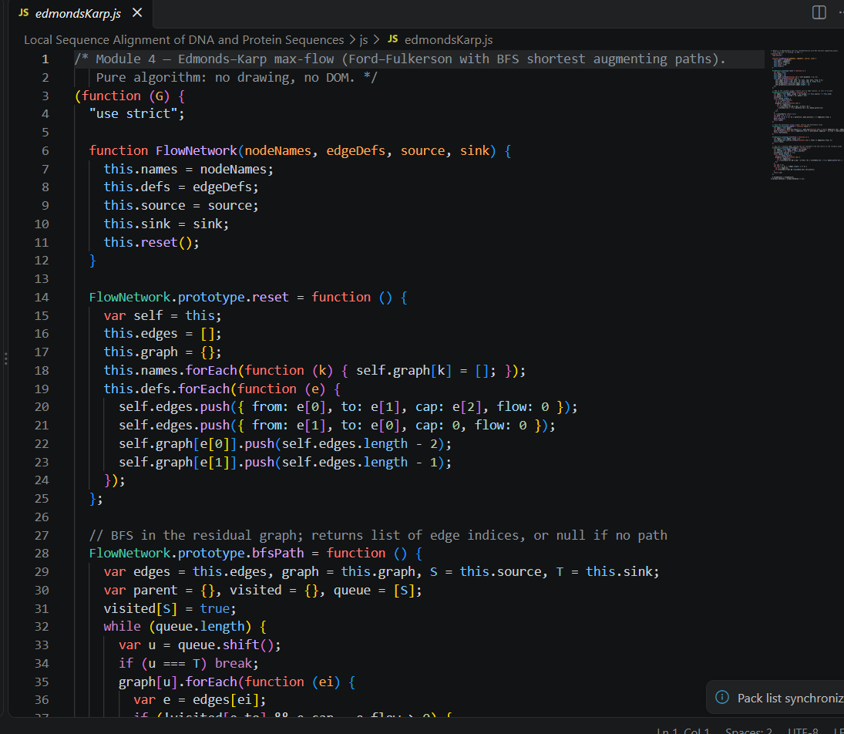
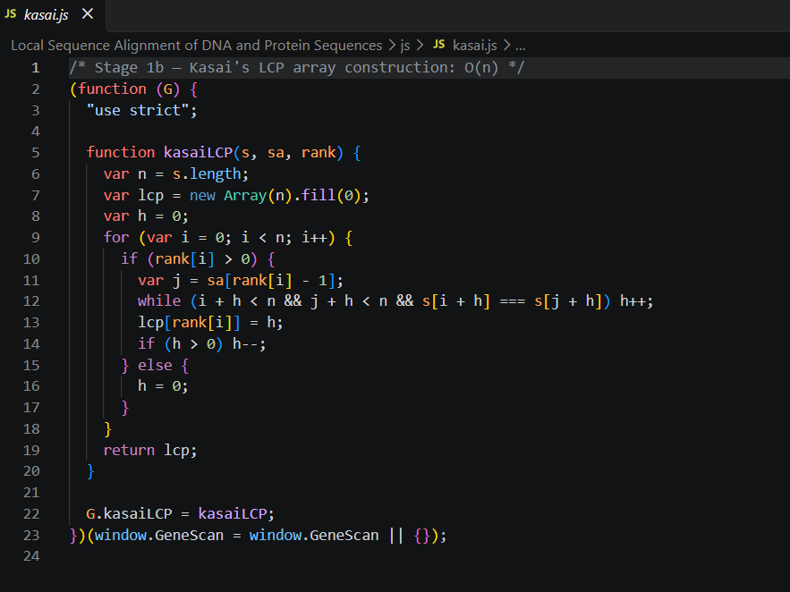

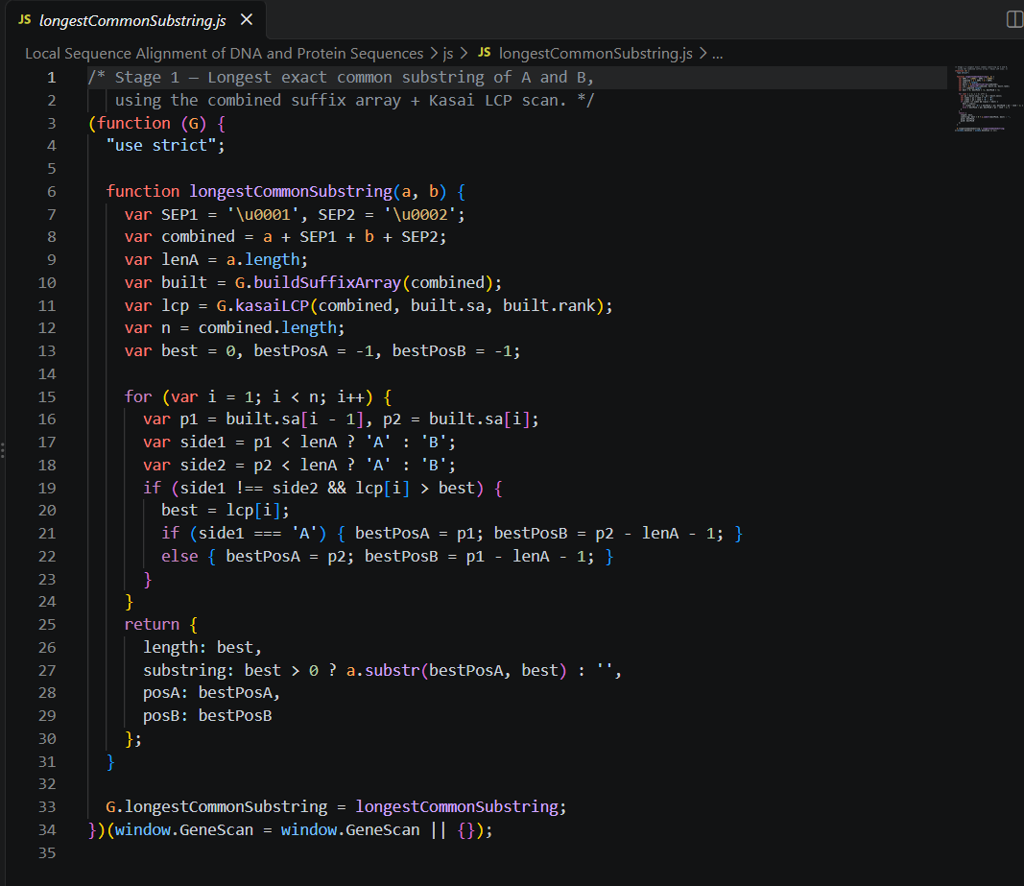

7. RESULTS & DISCUSSION

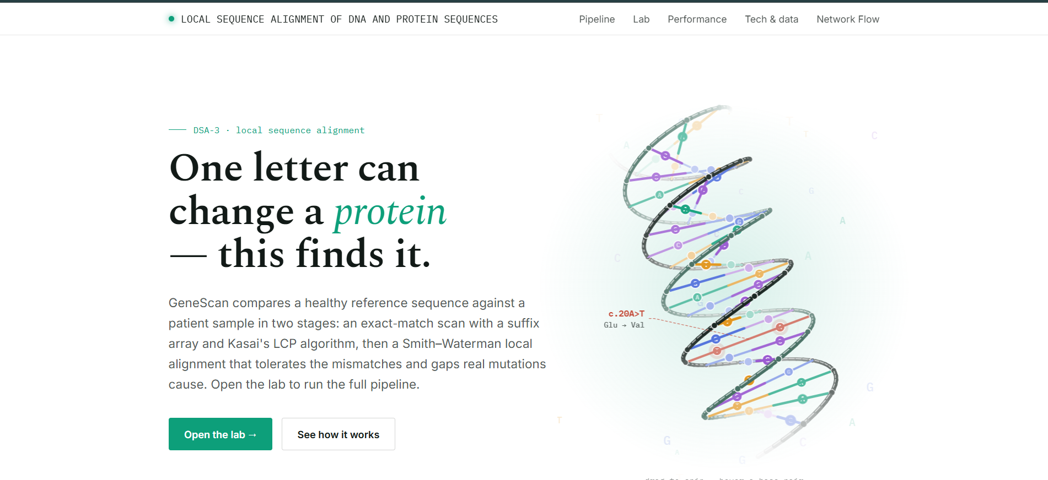
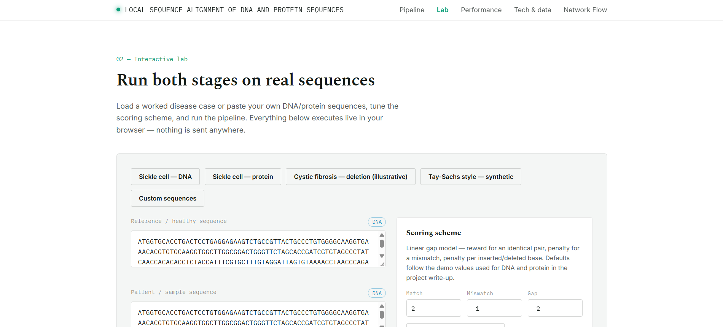
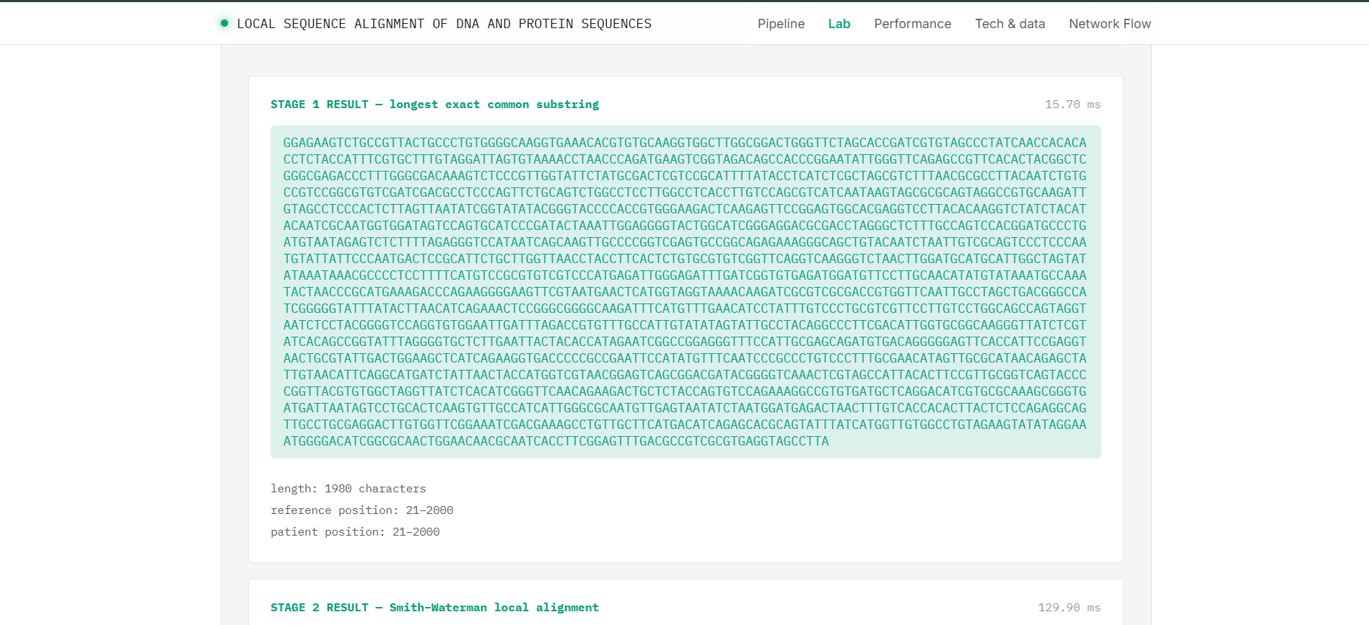
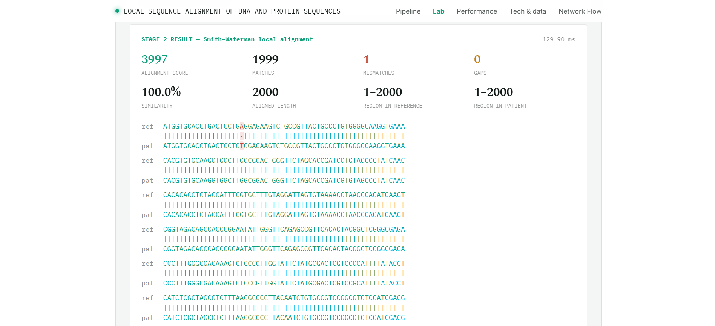

The system successfully performs local alignment of DNA and protein sequences using the Smith–Waterman algorithm and displays the optimal aligned region, alignment score, and similarity percentage.
The results demonstrate that the application can effectively identify similar and conserved regions, making sequence comparison easier and more understandable.

- CONCLUSION & FUTURE SCOPE

Conclusion
The project successfully developed a Java-based bioinformatics application for DNA and protein sequence comparison using the Smith–Waterman algorithm. The system provides an efficient method for identifying the most similar local regions between two biological sequences. It generates an alignment matrix, performs traceback, and displays the optimal local alignment along with the alignment score and percentage similarity.
The project also demonstrates the practical application of dynamic programming, two-dimensional arrays, and algorithmic problem-solving in the field of bioinformatics. By providing configurable match, mismatch, and gap scores, the application allows users to understand how different scoring parameters affect sequence alignment. Overall, the objectives of the project were achieved, and the developed system provides a simple and useful platform for learning and performing basic biological sequence analysis.
Future Scope
The project can be further enhanced with several additional features:
- Improved User Interface: Develop a more advanced and interactive graphical interface for easier sequence input and result visualization.
- FASTA File Support: Allow users to upload DNA and protein sequences directly from FASTA and other commonly used biological file formats.
- Alignment Visualization: Display the alignment matrix, traceback path, matching regions, gaps, and mismatches graphically.
- Database Integration: Connect the application with biological databases such as NCBI to compare user sequences with existing biological sequences.
- Large-Scale Analysis: Optimize the algorithm to handle longer sequences and multiple sequence comparisons efficiently.
- Advanced Analysis: Future versions can include mutation detection, conserved-region identification, evolutionary analysis, and additional sequence alignment algorithms.
- Machine Learning Integration: Machine learning techniques could eventually be incorporated to improve biological sequence classification and prediction.

- REFERENCES

• NCBI BLAST – Nucleotide BLAST
NCBI BLAST
• EMBOSS Water – Smith–Waterman Local Alignment
EMBOSS Water
• Biopython – Pairwise Sequence Alignment
Biopython Pairwise Alignment Documentation
• Bioinformatics Tools – Smith–Waterman Calculator
Smith–Waterman Alignment Calculator
• Jalview – Sequence Alignment and Analysis
Jalview
• Clustal Omega – Multiple Sequence Alignment
Clustal Omega
• MUSCLE – Multiple Sequence Alignment
MUSCLE
• JalviewJS – Web-Based Sequence Analysis
JalviewJS / Jalview Project

